Lab - Windows Task Manager

Objectives
In this lab, you will explore Task Manager and manage processes from within Task Manager.
Part 1: Working in the Processes tab
Part 2: Working in the Services tab
Part 3: Working in the Performance tab

Background / Scenario
The Task Manager is a system monitor program that provides information about the processes and programs running on a computer. It also allows the termination of processes and programs and modification of process priority.

Required Resources
- A Windows PC with internet access

Instructions

Working in the Processes tab
    - Open a command prompt and a web browser.
Microsoft Edge is used in this lab; however, any web browser will work. Just substitute your browser name whenever you see Microsoft Edge.
    - Right-click the Task bar to open Task Manager. Another way to open the Task Manager is to press Ctrl-Alt-Delete to access the Windows Security screen and select Task Manager.
    - Click More details to see all the processes that are listed in the Processes tab.
    - Expand the Windows Command Processor heading.

Question:
What is listed under this heading?
Type your answers here.
    - There are three categories of processes listed in the Processes tab: Apps, Background processes, and Windows processes.
- The Apps are the applications that you have opened, such as Microsoft Edge, Task Manager, and Windows Command Processor, as shown in the figure above. Other applications that are opened by the users, such as web browsers and email clients, will also be listed here.
- The Background processes are executed in the background by applications that are currently open.
- The Windows processes are not shown in the figure. Scroll down to view them on your Windows PC. Windows processes are Microsoft Windows services that run in the background.
Some of the background processes or Windows processes may be associated with foreground processes. For example, if you open a command prompt window, the Console Window Host process will be started in the Windows process section, as shown below.
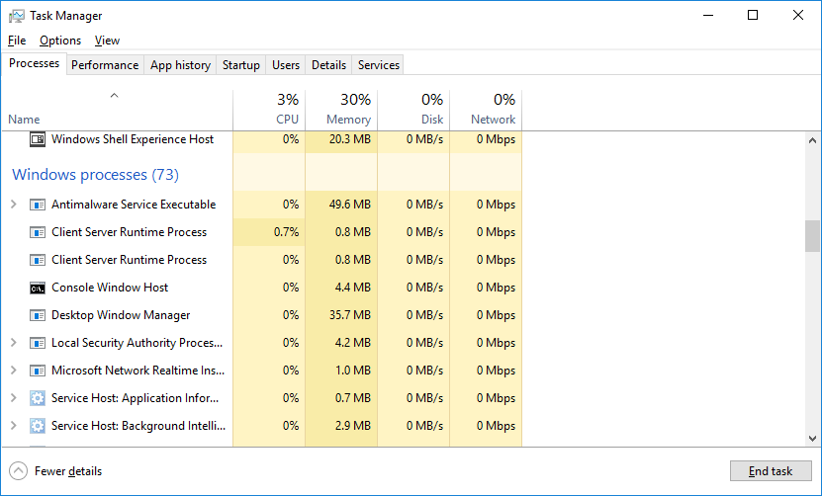
    - Right-click Console Window Host and select Properties.

Question:
What is the location of this filename and location of this process?
Type your answers here.
    - Close the command prompt window.

Question:
What happens to Windows Command Processor and Console Window Host when the command prompt window is closed?
Type your answers here.
    - Click the Memory heading. Click the Memory heading a second time.

Question:
What effect does this have on the columns?
Type your answers here.
    - Right-click on the Memory heading, and then select Resource values > Memory > Percents.
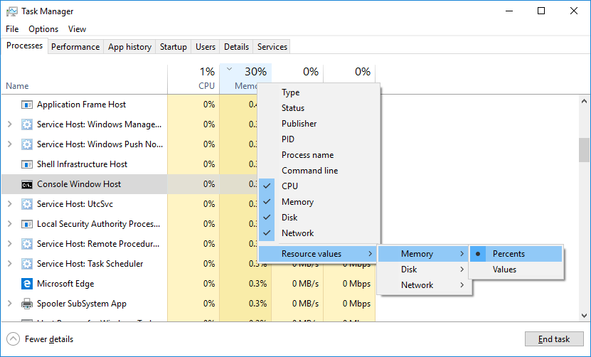

Questions:
What affect does this have on the Memory column?
Type your answers here.
How could this be useful?
Type your answers here.
    - In the Task Manager, click the Name heading.
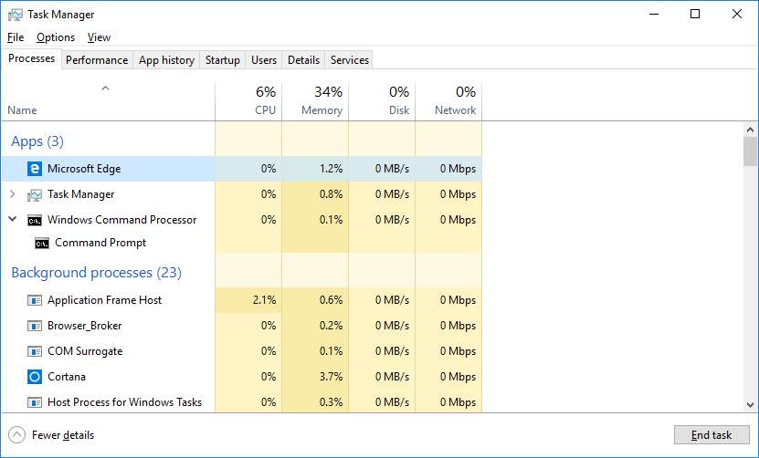
    - Double-click the Microsoft Edge.

Question:
What happens?
Type your answers here.
    - Return to the Task Manager and right-click Microsoft Edge. Select End task.

Question:
What happens to the web browser windows?
Type your answers here.

Working in the Services tab
In the Task Manager window, click the Services tab. Use the scroll bar on the right side of the Services window to view all the services listed.

Question:
What statuses are listed?
Type your answers here.

Working in the Performance tab
    - In the Task Manager window, click the Performance tab.
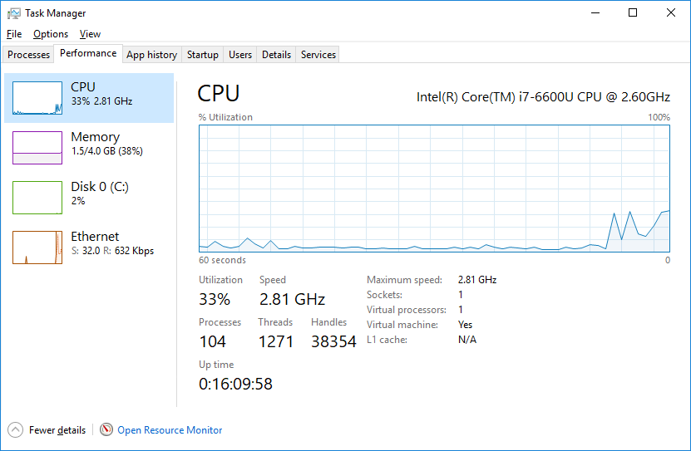

Questions:
How many threads are running?
Type your answers here.
How many processes are running?
Type your answers here.
    - Click the Memory in the left panel of the Performance tab.
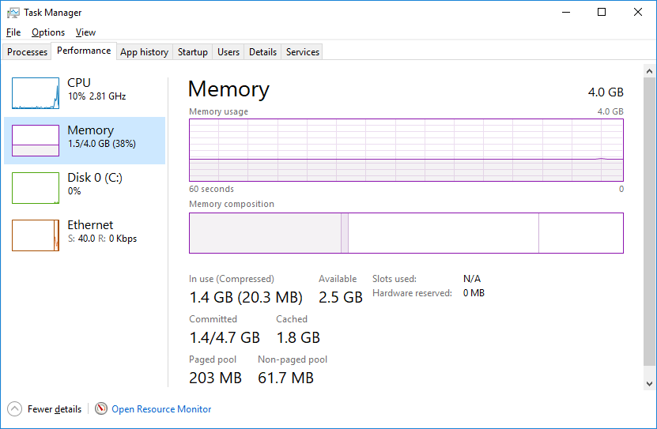

Question:
What is the total physical memory (MB)?
Type your answers here.
What is the available physical memory (MB)?
Type your answers here.
How much physical memory (MB) is being used by the computer?
Type your answers here.
    - Click the Ethernet Chart in the left panel of the Performance tab.
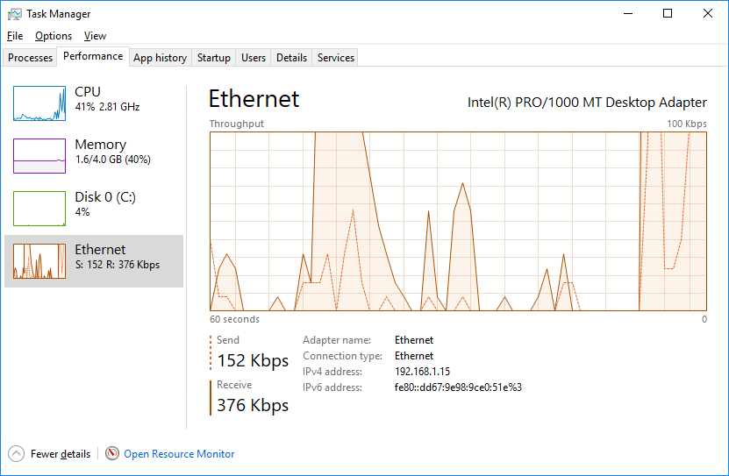

Questions:
What is the link speed?
Type your answers here.
What is the IPv4 address of the PC?
Type your answers here.
    - Click Open Resource Monitor to open the Resource Monitor utility from the Performance tab in Task Manager.
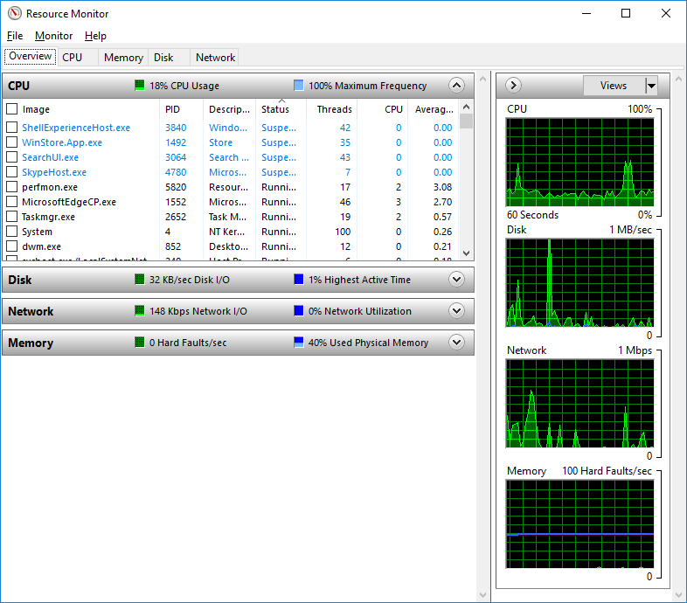

Reflection Question
Why is it important for an administrator to understand how to work within the Task Manager?

Lab Answers
Part1:
d. Under the Windows Command Processor heading Command Prompt is listed.
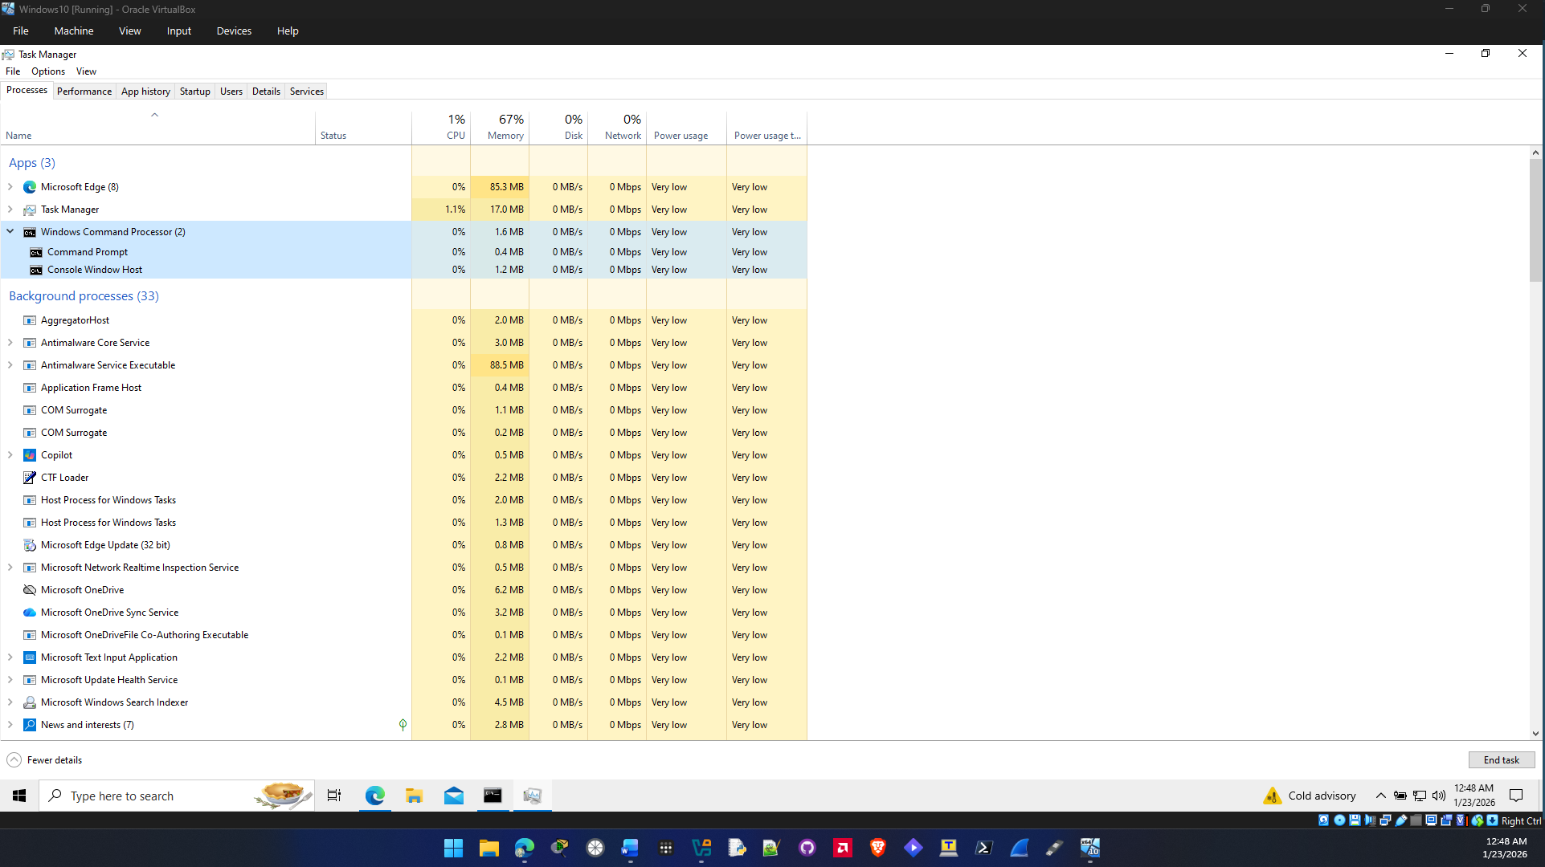

f. The filename associated with Console Window Host is conhost.exe and its path is C:\Windows\System32.
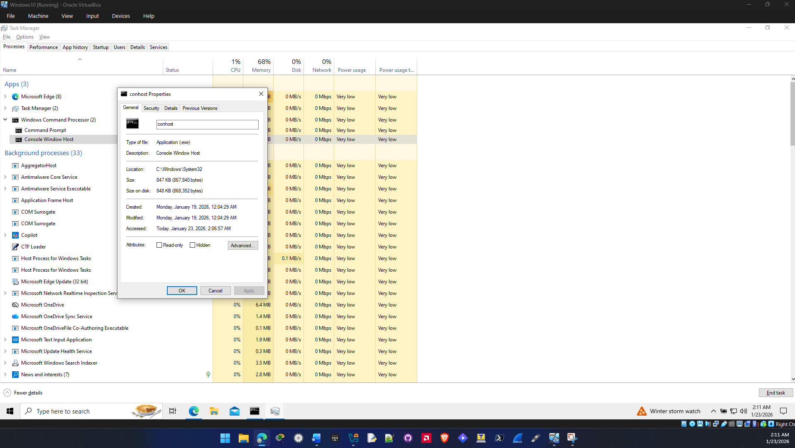
g. When the cmd window is closed the Windows Command Processor is not listed in task manager anymore as well as the child processes.

h. Clicking the memory heading sorts the processes by the amount of memory each one uses. When I clicked it the first time it sorted it from larget to smallest and a second time sorts it from smallest to largest then it repeats.

i. The memory column displays the app and process usage in a percentage value instead of a raw value. This is useful because it can show you the total percentage of memory that services are using and may be used to diagnose and troubleshoot issues related to memory in windows.
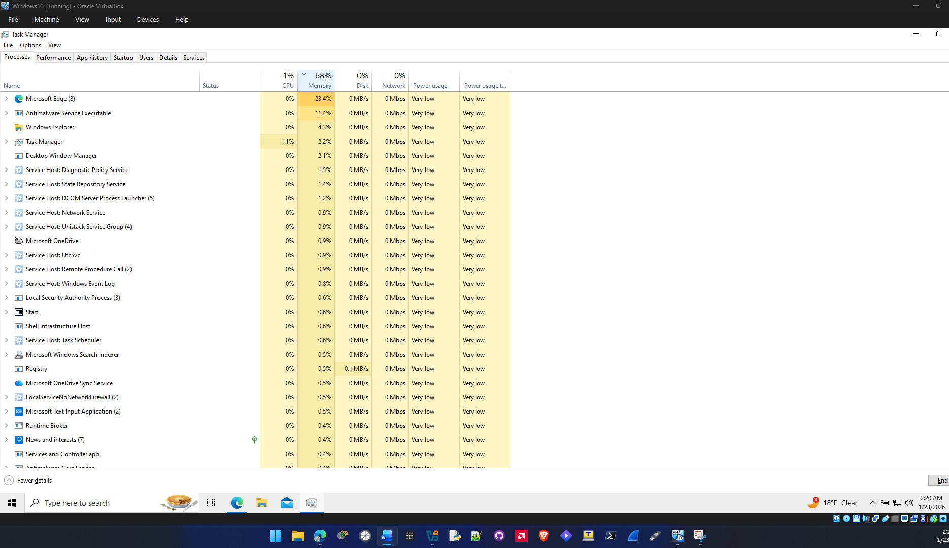

k. Double clicking the Microsoft Edge process expands the process and shows more details to how your computer is using the process like cpu and gpu usage, and what utilities msedge is using.
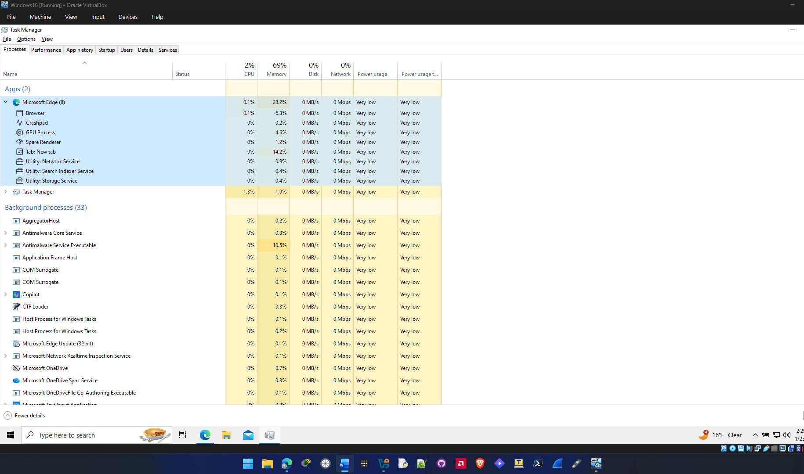

l. Ending the Microsoft edge task causes it to disappear from task manager and closes all tabs.
Part 2:
The statuses listed in the Services tab in task manager are Stopped and Running.
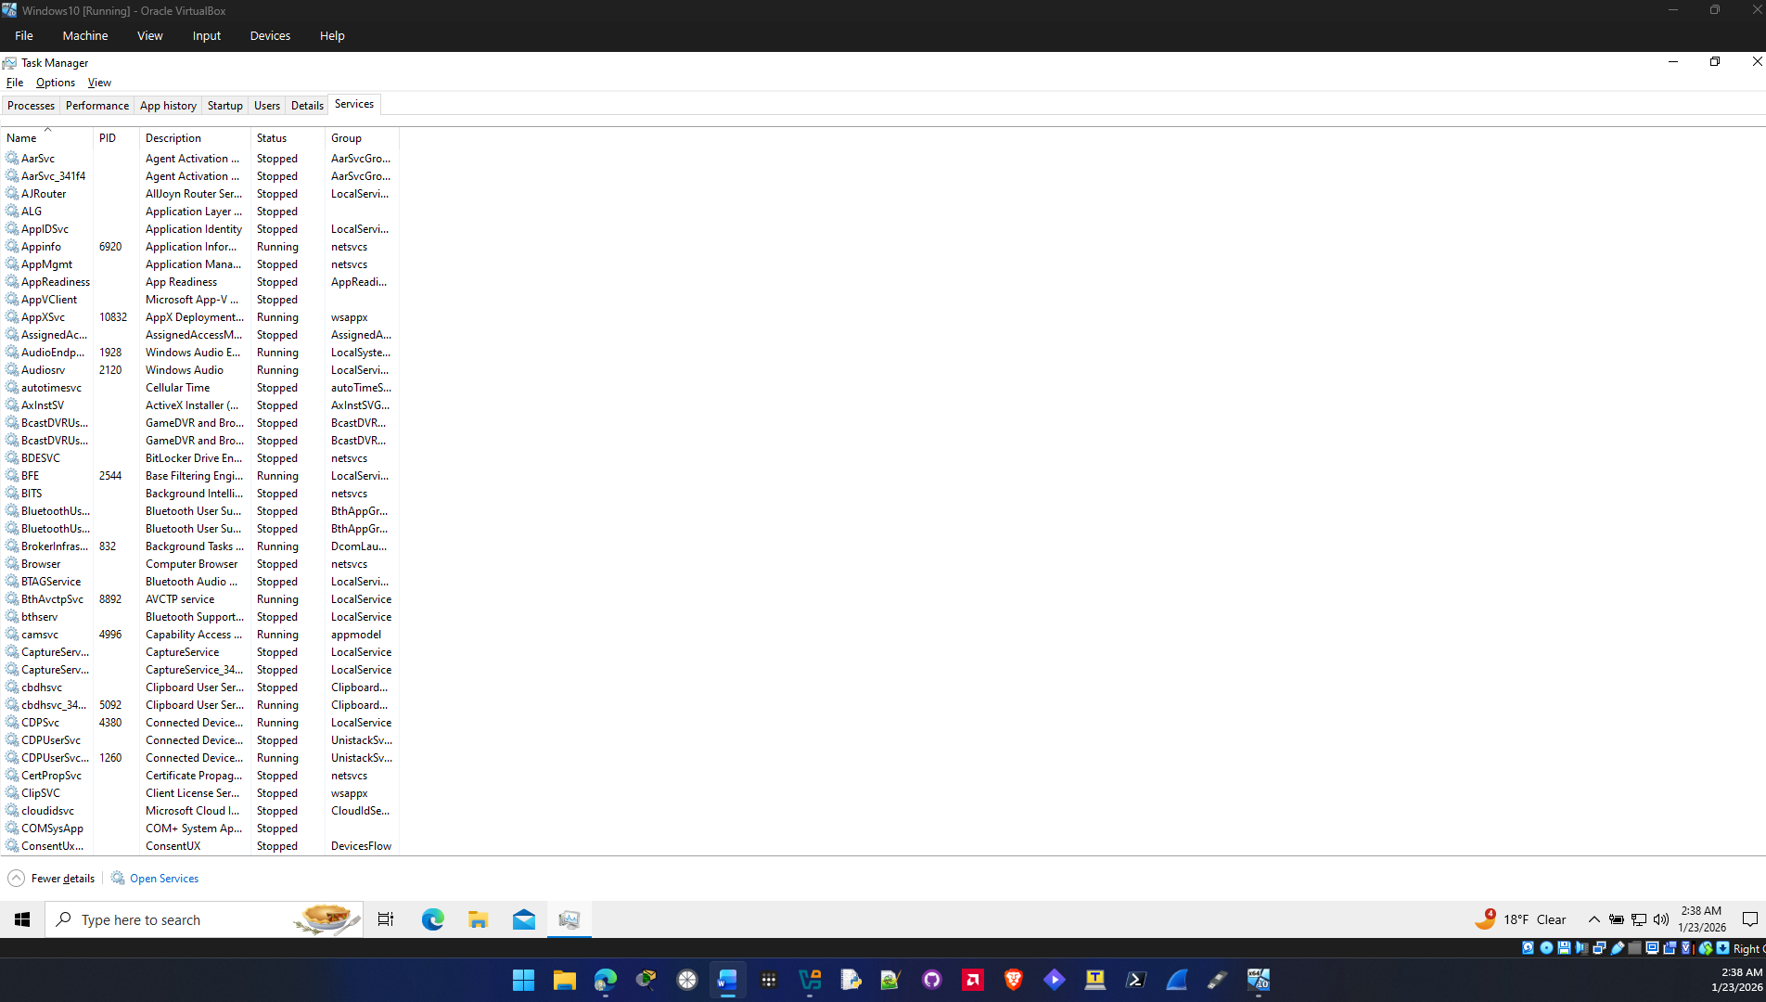
Part 3:
a. On my VM in the CPU tab 1381 threads running is displayed and 134 processes running is displayed.
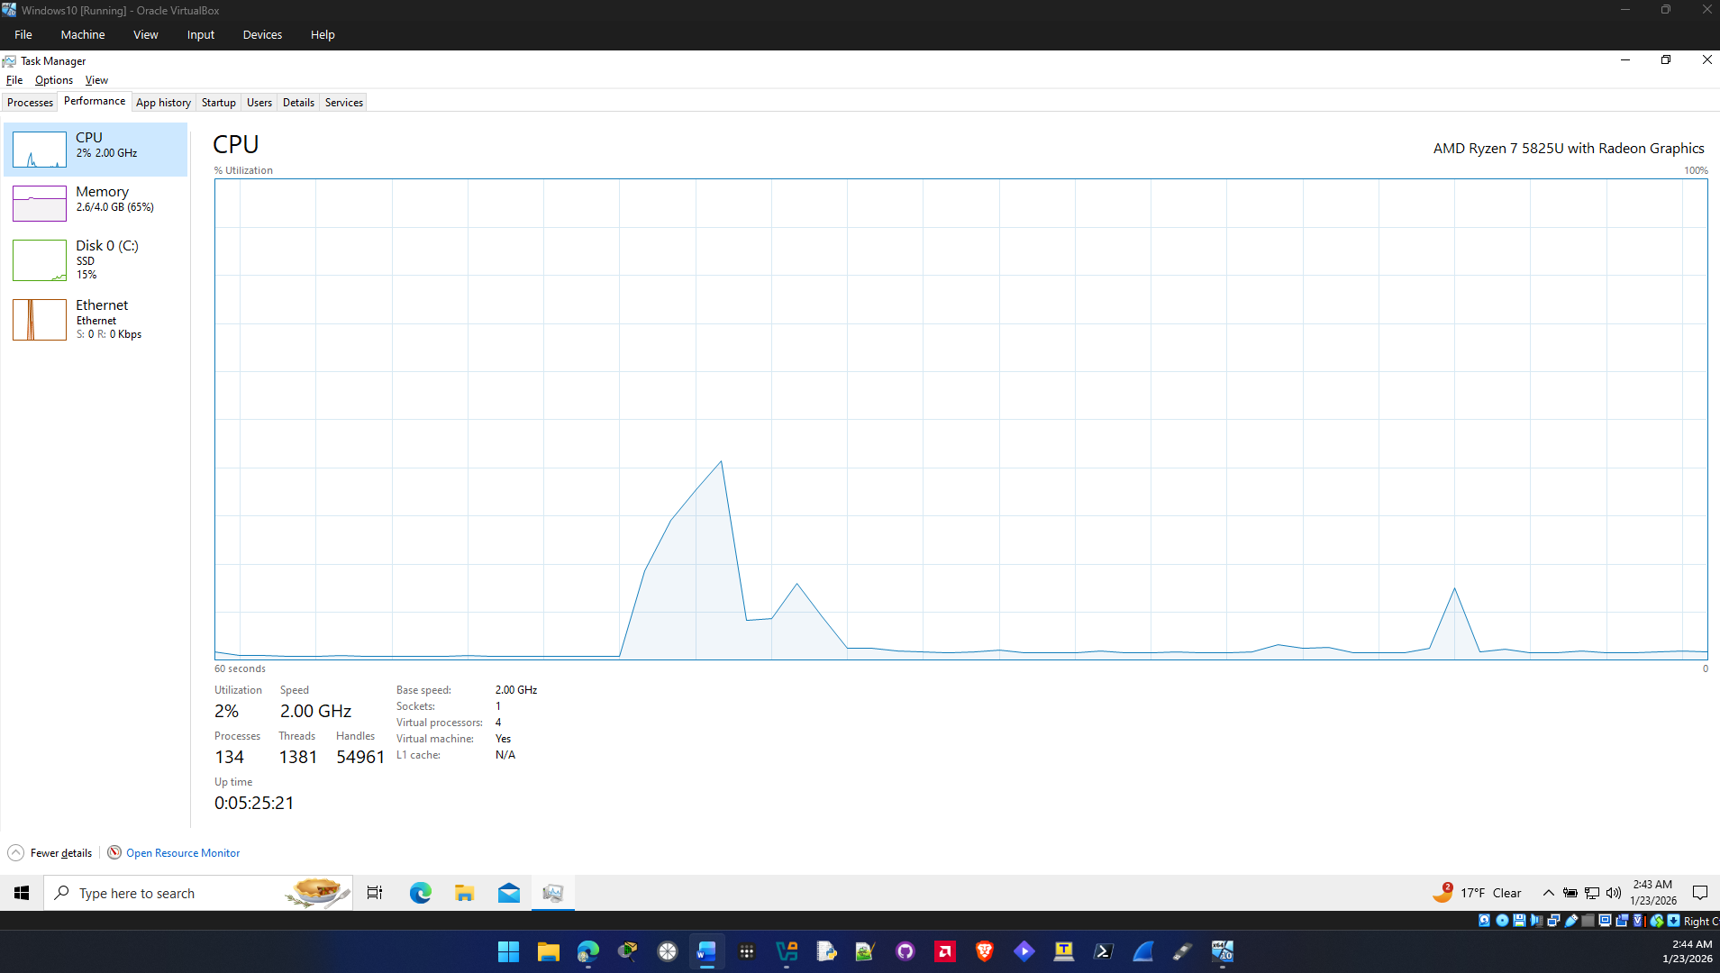

b. The total physical memory is 4 GB, the available physical memory is 1.4 GB and the physical memory being used by my VM is 3.8 GB.
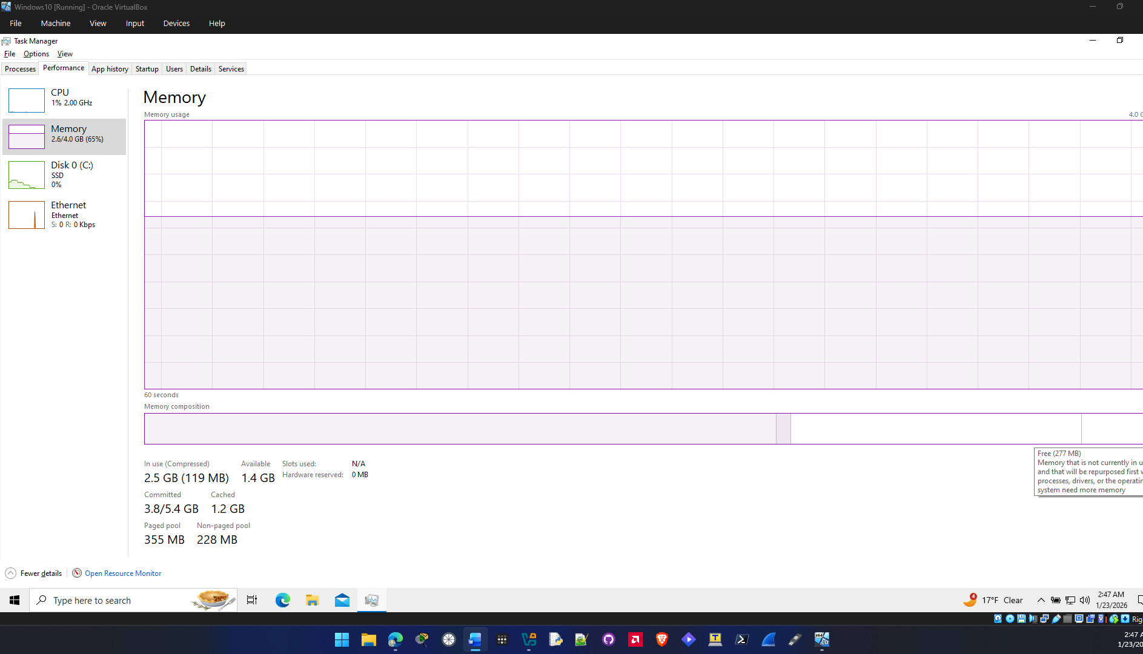

c. The link speed of my VM is is 1000mbps and The IPv4 address of this VM is 10.0.2.15.
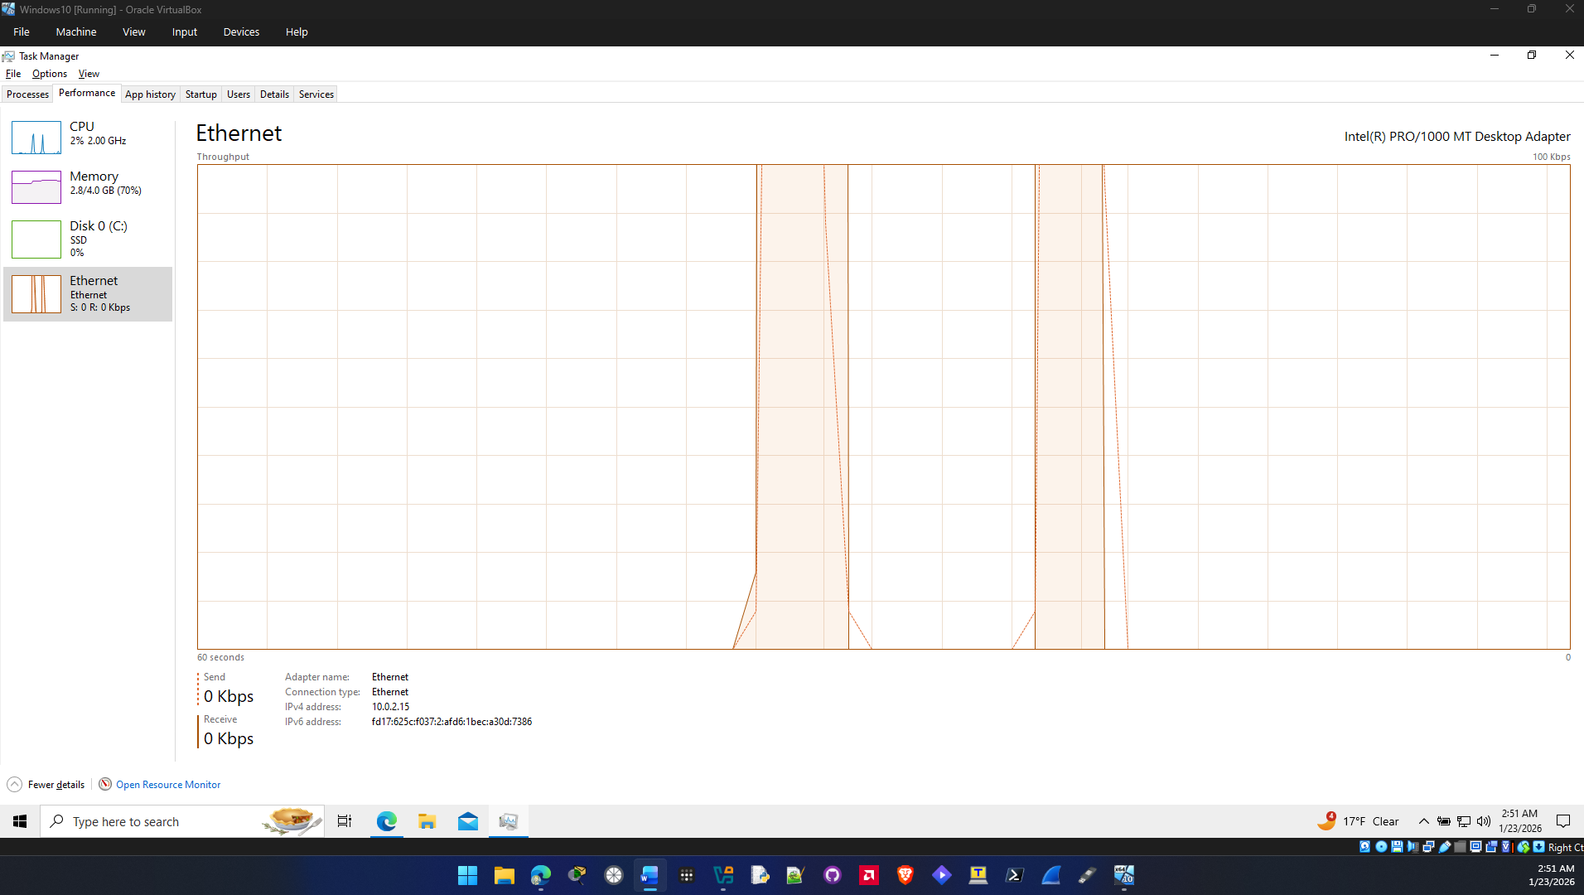

Reflection Question
It’s important to understand the task manager as an admin because it can be used as a tool for troubleshooting problems on windows. It does this by providing information about the cpu, memory, disk, and network usage. It also gives a way to end programs and kill processes.
Type your answers here.
End of document

